A000-Asia-China-Shang-Gui-Dragons, monsters and taotie-Bronze-1200 BCE

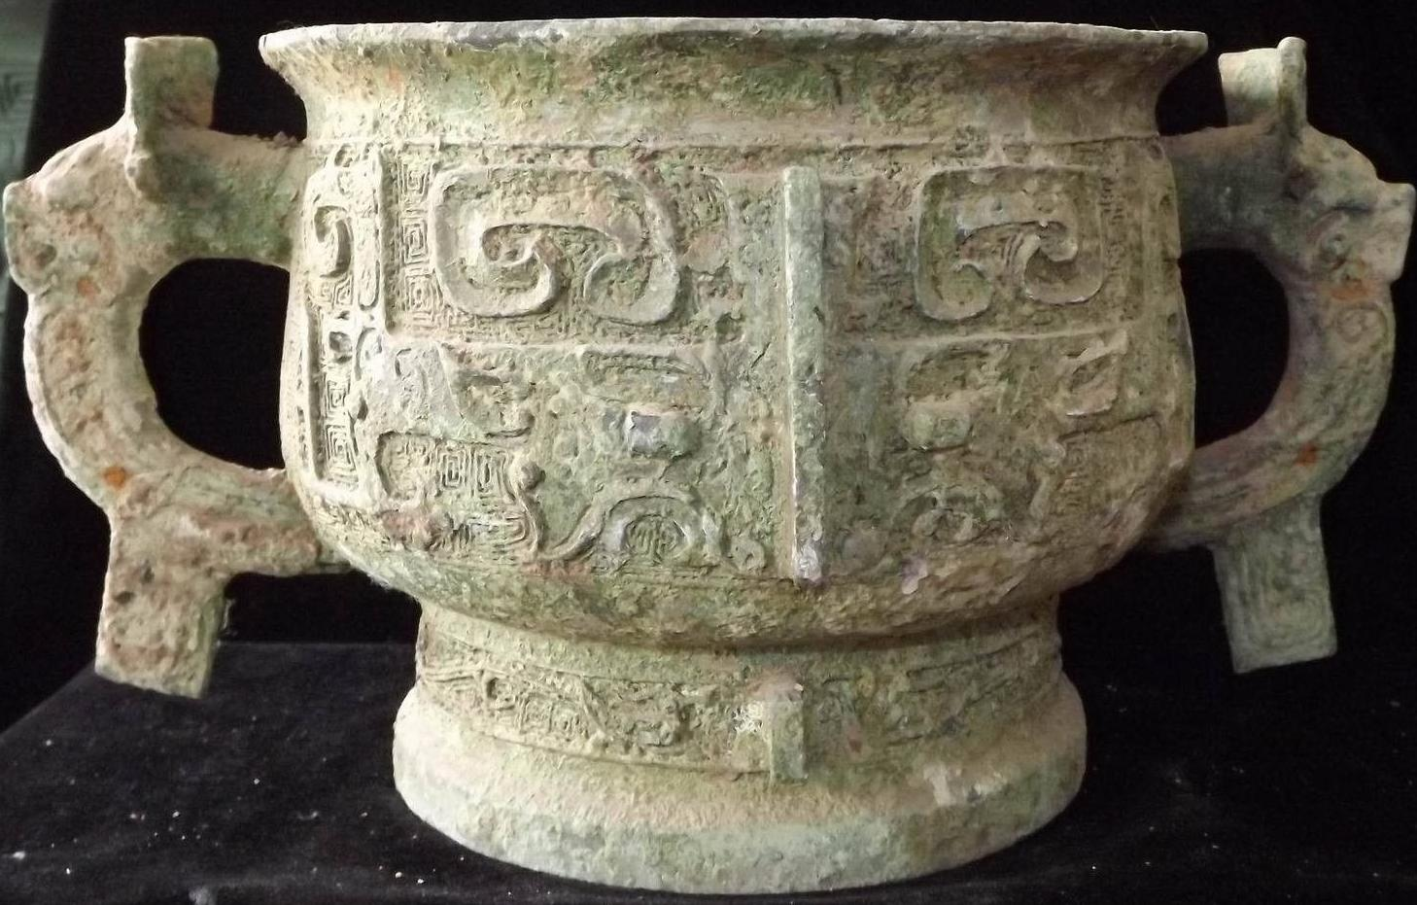

Case No.: 5

**Accession No.**

**Formal Label:** China-Shang-Gui-Dragons, monsters and taotie-Bronze-1200 BCE

**Display Description:**

Bronze 'gui', decorated with dragons, monsters and 'taotie'.

'Gui' is a ritual vessel for offering food. For much of the Shang, 'gui' seem to have been made without handles and these are sometimes termed 'yu'; from late Shang and throughout the Zhou most 'gui' had two handles, although a few were cast with four.

A comparable example is in the Avery Brundage Collection ( d'Argencé 1967:34-35, no. IX).

**LC Classification:**

**Date or Time Horizon:**

**Geographical Area:**

**Map:**

**GPS coordinates:**

**Cultural Affiliation:**

**Media:**

**Dimensions:**

**Weight:**

**Condition:**

**Provenance:**

**Discussion:**

**References:**

NK7983.

Period: Shang (18th–12th century bce)

H: x Dia. Vessel: Max. Dia.: A comparable example is in the Avery Brundage Collection ( d'Argencé 1967:34-35, no. IX).

References:

d'Argencé, René-Yvon Lefebvre. 1967. Bronze vessels of ancient China in the Avery Brundage Collection. San Francisco: Asian Art Museum of San Francisco. [Berkeley, Calif.]: Published by Diablo Press for the De Young Museum Society.

